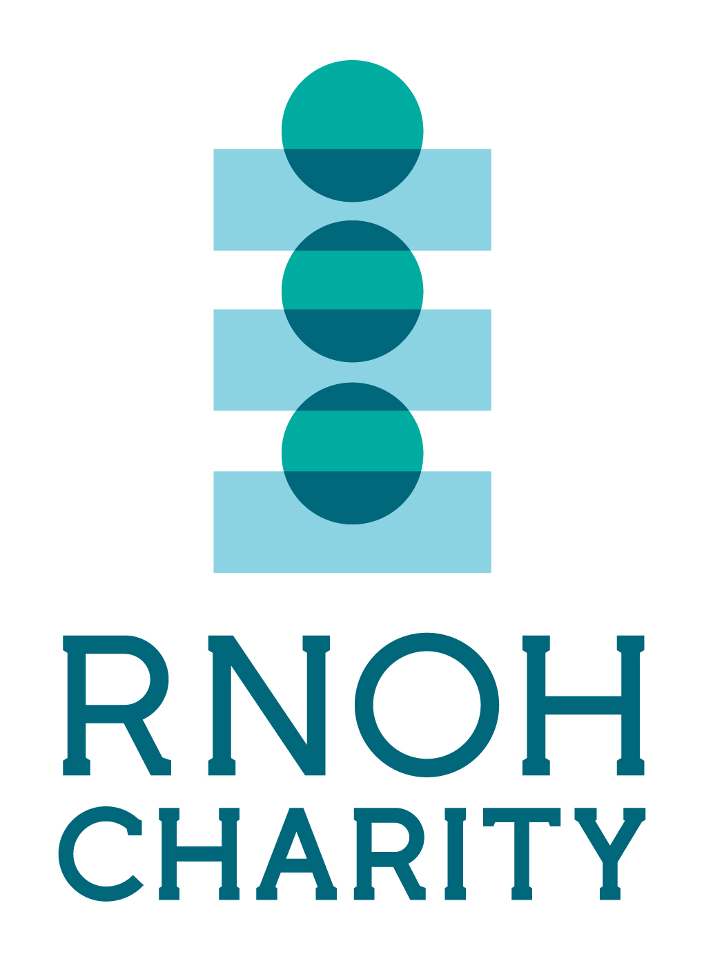
BECOME AN RNOH CHARITY COMMUNITY CHAMPION!

We are looking for RNOH Charity Champions to be the face of our cause in your community! If you can spare some time now and again to put the word out for us to your local schools, community spaces and in your social media groups, we would love to hear from you.

If you’re interested in the role, please fill in the form below and return it to us at rnoh.charity@nhs.net. Thank you and we look forward to hearing from you soon.

Name ………………………………………………………………………………………………………………….............
Address …………………………………………………………………………………………………………………………..
……………………………………………………………………… Post Code …………………………………………….
Email ……………………………………………………………………………………………………………………………….
Tel ……………………………………………… Date of Birth ……………………………………………………

Place of work/school…………………………………………………………………………………………………………

Do you have a personal connection to the Royal National Orthopaedic Hospital?
……………………………………………………………………………………………………………………………………………
……………………………………………………………………………………………………………………………………………
…………………………………………………………………………………………………………………………………………..

Why would you like to become an RNOH Charity Community Champion?
…………………………………………………………………………………………………………………………………………
…………………………………………………………………………………………………………………………………………
…………………………………………………………………………………………………………………………………………
…………………………………………………………………………………………………………………………………………
…………………………………………………………………………………………………………………………………………
…………………………………………………………………………………………………………………………………………

What would you like you gain from the role?
…………………………………………………………………………………………………………………………………………….
…………………………………………………………………………………………………………………………………………….
……………………………………………………………………………………………………………………………………………..
……………………………………………………………………………………………………………………………………………..
If you are under 16, please ask your parent/guardian to confirm they are happy for you to become an RNOH Charity Community Champion.
Parent/guardian name…………………………………………………………………………………………………..
Address…………………………………………………………………………………………………………………………..
………………………………………………………………. Post Code ……………………………………………………..
Email………………………………………………………………………………………………………………………………..
Tel……………………………………………………………… Signature…………………………………………………….
[ ] I consent for my details to be added to the RNOH Charity database so that we can send you regular updates by post.
[ ] I consent for my details to be added to the RNOH Charity database so that we can send you regular updates by email.
You have the right to withdraw consent to receiving information from RNOH Charity at any time by writing to us stating your details, or by emailing rnoh.charity@nhs.net
Registered Charity No: 1166129

