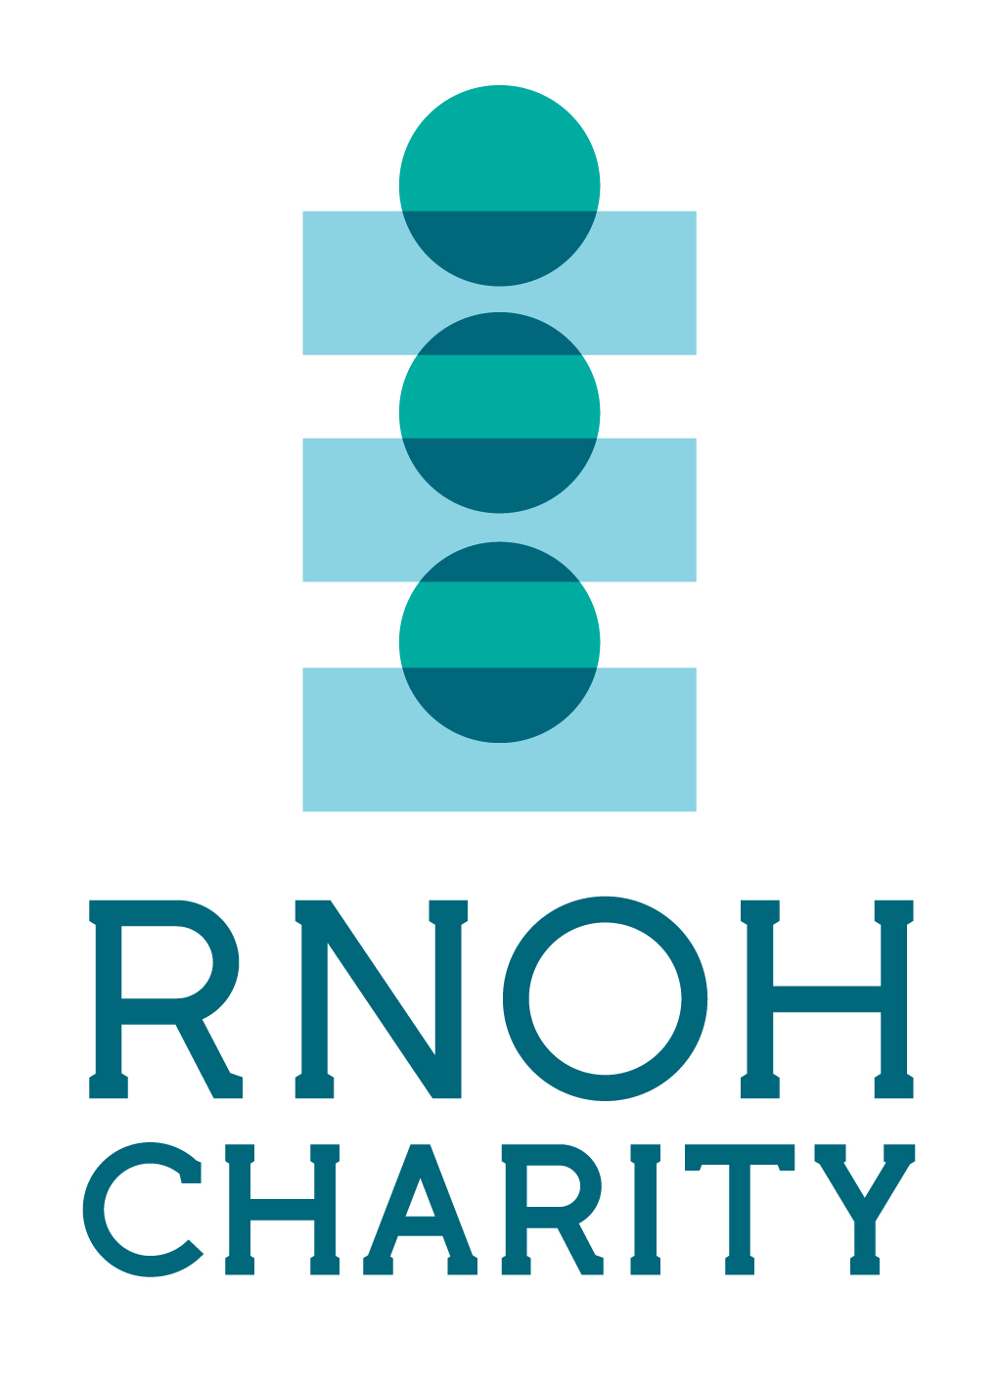

Role: RNOH Charity Community Champion
Responsible to: Community Fundraising Manager
Time commitment: To suit your availability
About RNOH Charity:
RNOH Charity strengthens the vital work of the Royal National Orthopaedic Hospital (RNOH) on an on-going basis by providing extra services and facilities that are beyond the reach of the hospital’s NHS budget.
The funds raised by the Charity help the hospital to provide world-class care for all its patients and support the hospital's pioneering work in orthopaedic research and education.
Volunteer RNOH Charity Community Champions help to raise awareness of our cause by attending events/workshops/assemblies to talk about our work or let others know about us through Charity materials to encourage others to get involved in fundraising activity. This is a really important role as it helps us to reach new people, inspire new fundraising activity, and thank our supporters for the work they are doing.
World-leading specialists need world-leading support.
Role description:
• Serve as a community voice for, and represent, RNOH Charity within your local area
• Update Charity information/posters/leaflets in your local area or online
• Make conversation with members of the public as appropriate, and answer questions about the Charity
•Organising events to actively fundraise for the Charity
• Attending events/workshops/assemblies to promote planned fundraising initiatives and activities
The benefits to you
• Experience working with a professional organisation
• A sense of satisfaction and pride in helping to make a valuable difference
• Develop your skills
• References for future employers
• Meet new people
Skills, experiences and qualities
• Personable, enthusiastic and approachable
• Able to act on own initiative
• Confidence in public speaking (desirable but not essential)
•Willingness to learn about RNOH Charity
Time commitment:
This is a flexible role to suit your availability, and as such there is no minimum time commitment.
Next step
If you have any questions, please contact us on 020 8909 5362 or email rnoh.charity@nhs.net

